EX. NO.: 13
TITLE
SIMPLE PROGRAMMING USING CASE AND LOOP
AIM
To learn how to use various MySQL programming statements including CASE and LOOP to run a block of code repeatedly based on a condition.

PROCEDURE
CASE STATEMENT
- In MySQL, the CASE statement has the functionality of an IF-THEN-ELSE statement.
- The CASE statement evaluates the given condition.
- If the condition is satisfied, the corresponding statement is executed.
- The ELSE statement is executed when none of the conditions are satisfied.
LOOP STATEMENT
- The LOOP statement enables repeated execution of a statement list.
- The statements within the loop are repeated until the loop is terminated.
- The LEAVE statement is generally used to terminate the loop.
- The ITERATE statement causes the loop to repeat from the beginning.

PROGRAM-1
Write a function that uses CASE statement where if monthly_value is equal to or less than 4000, then income_level will be set to 'Low Income'. If monthly_value is equal to or less than 5000, then income_level will be set to 'Avg Income'. Otherwise, income_level will be set to 'High Income'.
1. Select Database
USE MobileDB;

2. Create Function Using CASE
DELIMITER //

CREATE FUNCTION IncomeLevel(monthly_value INT)
RETURNS VARCHAR(20)
DETERMINISTIC
BEGIN
DECLARE income_level VARCHAR(20);

CASE
WHEN monthly_value <= 4000 THEN
SET income_level = 'Low Income';

WHEN monthly_value <= 5000 THEN
SET income_level = 'Avg Income';

ELSE
SET income_level = 'High Income';
END CASE;

RETURN income_level;
END //

DELIMITER ;
3. Display Income Level
SELECT IncomeLevel(3500);

PROGRAM-2
Write a function that will use ITERATE statement which would cause the loop to repeat while income is less than 4000. Once income is greater than or equal to 4000, the LOOP will be terminated.
1. Create Function Using LOOP and ITERATE
DELIMITER //

CREATE FUNCTION LoopExample()
RETURNS INT
DETERMINISTIC
BEGIN
DECLARE income INT DEFAULT 1000;

income_loop: LOOP

SET income = income + 1000;

IF income < 4000 THEN
ITERATE income_loop;
END IF;

LEAVE income_loop;

END LOOP;

RETURN income;
END //

DELIMITER ;

2. Display the Final Income
SELECT LoopExample();

OUTPUT
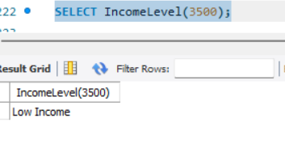
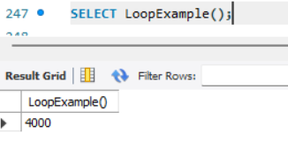
RESULT
Thus the Simple programming exercise using CASE and LOOP was executed successfully.

